
FIRST TERM EXAMINATION (2023-24)
Subject: PHYSICS (ANSWER KEY)  Grade: XII |  |  | Max. Marks:70  Time: 3 Hrs
SECTION A
This section consists of 10 multiple choice questions
- 1
 |  | 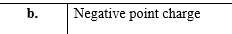 |  |  | 1
 |  | 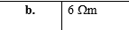 |  |  | 1
 |  |  |  |  | 1
 |  |  |  |  | 1
 |  |  |  |  | 1
 | 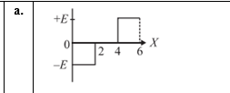 |  |  |  | 1
 |  |  |  |  | 1
 |  |  |  |  | 1
 |  |  |  |  | 1
 | 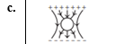
 | 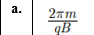
 | 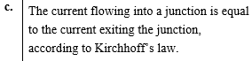
Assertion reason
16. | D |  |  |  | 1
17. | C |  |  |  | 1
18. | B |  |  |  | 1
II | SECTION B
19. | 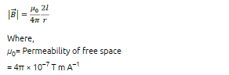 |  |  |  | 2
 | 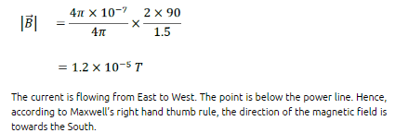
20. | 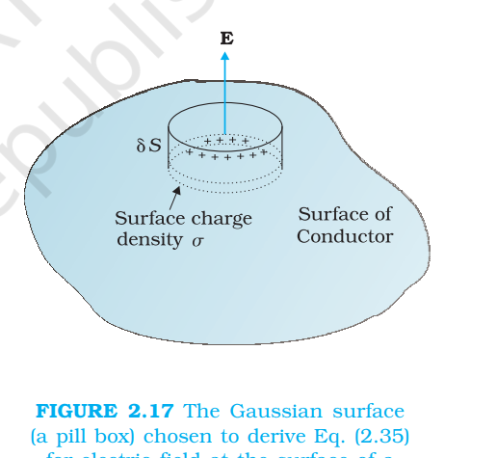 |  |  |  | 1
 | 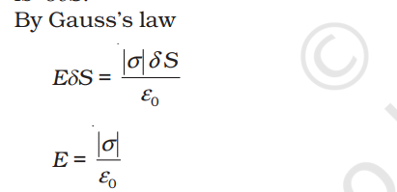 |  |  |  | 1
21. | 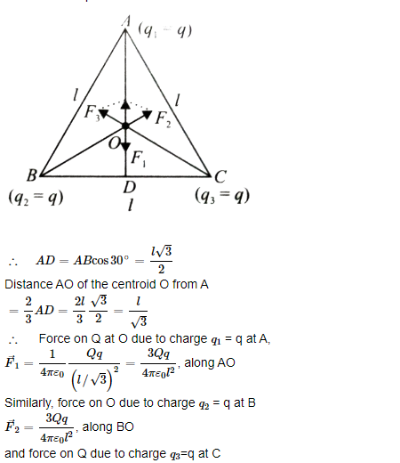------------------1  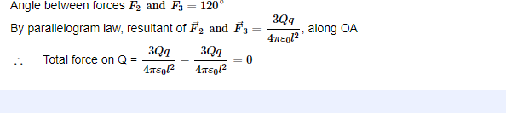--------------------------------1 |  |  |  | 2
22 | Electric field is established throughout the circuit, almost instantly (with the speed of light) causing at every point a local electron drift. Establishment of a current does not have to wait for electrons from one end of the conductor travelling to the other end. However, it does take a little while for the current to reach its steady value. |  |  |  | 1
 | In the absence of electric field, the paths are straight lines; in the presence of electric field, the paths are, in general, curved. |  |  |  | 1
23 | 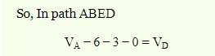 |  |  |  | 1
 | 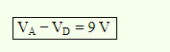 |  |  |  | 1
24 | 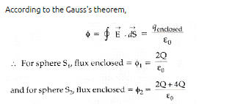 |  |  |  | 1
 | 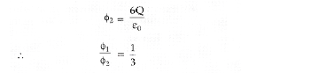 |  |  |  | 1
25. | (a) Manganin and constantan alloys are used to make standard resistance coils because.  they have high resistivity, a low-temperature coefficient of resistance, |  |  |  | 1
 | (b) 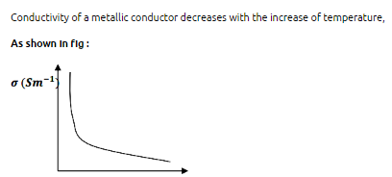 |  |  |  | 1sss
III | SECTION C
26. | FIG ----------------------------1/2  NET FORCE =0-----------------1  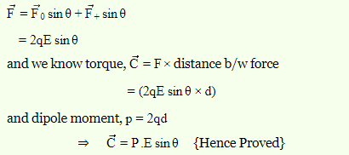-----------1.5  OR  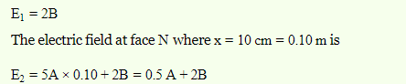--------------1  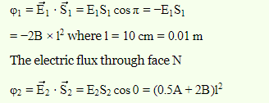----------------------------------------1  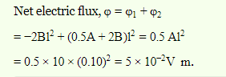-----------------------------------1 |  |  |  | 3
27. | -------------1  -----------------1  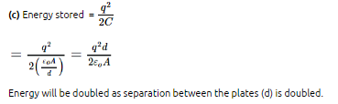-----------------------1 |  |  |  | 3
28. | Applying WSB , C5 NEGLECTED ----------------------------1/2  Equivalent capacitance = 2µF --------------------------------------------1  Charge = 10 µC -----------------------------------------1/2  Energy = 25 µJ ----------------------------------------1 |  |  |  | 3
29. | 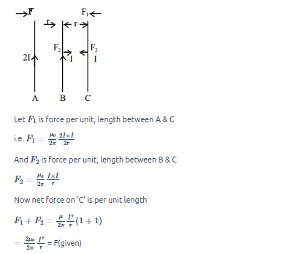  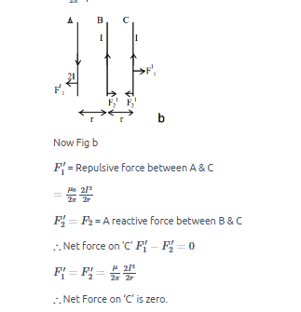 |  |  |  | 2
30. | 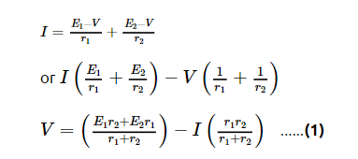
30 | 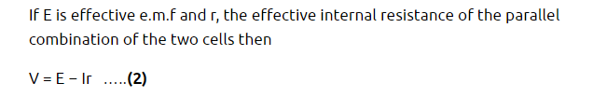  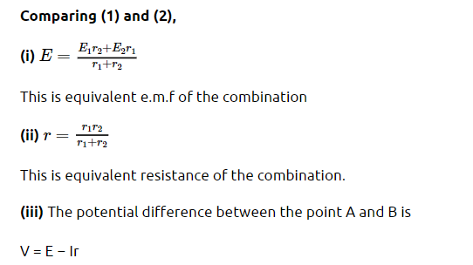 |  |  |  | 2
IV | SECTION D
31. | Fig -----------------------------------1/2  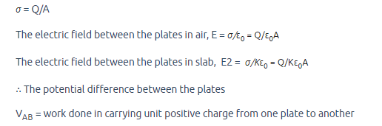  -------------------1  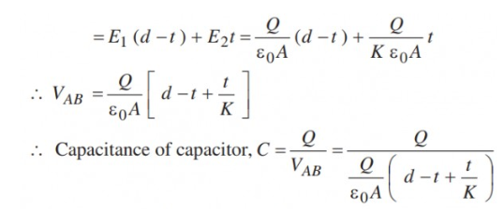  -------------1  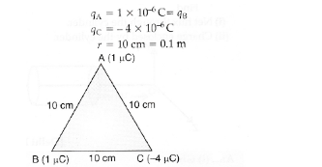--------- 1 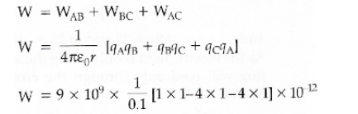--------------------1  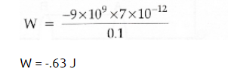--------------------------1/2  OR  - Fig --------------------------------------1  Proof ------------------------------------1  b)  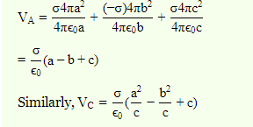-----------------2  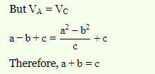--------------------------------1 |  |  |  | - 5
32. | a) proof ---------------------------------------------3  b) kQ/4a² to the right (+x)--------------------2 |  |  |  | 5

OR

a) proof ---------------------------------------------------------------------------------------------------3
b)
At A -σ/2 ε0 along – y axis---------------1
AT C , +7σ/2ε0 along -y axix--------------1
33. | - Vector form -------------------1/2  Derivation ------------------2  b)  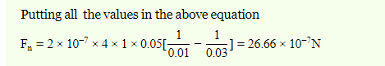-----------------2  Towards left ------------------------------------------------------------------------1/2  OR  - Principle ------------------1/2  Fig ----------------------1/2  Proof -----------------------2  b)  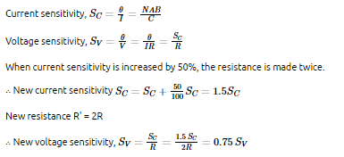------------------1  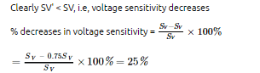------------------------------2 |  |  |  | 5
V | SECTION E
 | CASE STUDY
34. | 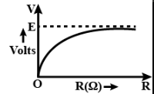---------------------1
 | E₁/r₁ = E₂/r₂ = E₃/r3---------------------------------------------1
Slope of the graph = r _{eq =} 6/1 =6 ohm-----------------------1
r= 6/3= 2 ohm -------------------------------------------------1
OR
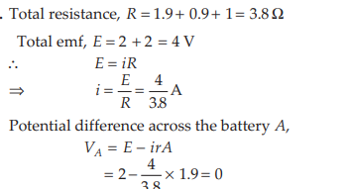

36 | 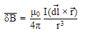----------------------------------------------------------1
 | Any one suitable ---------------------------------------------------------1
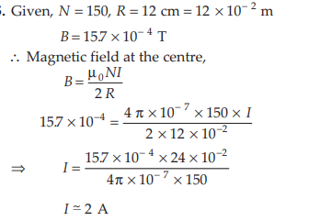----------------------------------------2
OR
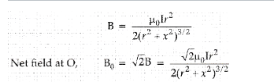-----------------------1.5
The direction of B0 is 45° with the axis of any of the two loops. -----------0.5
***

